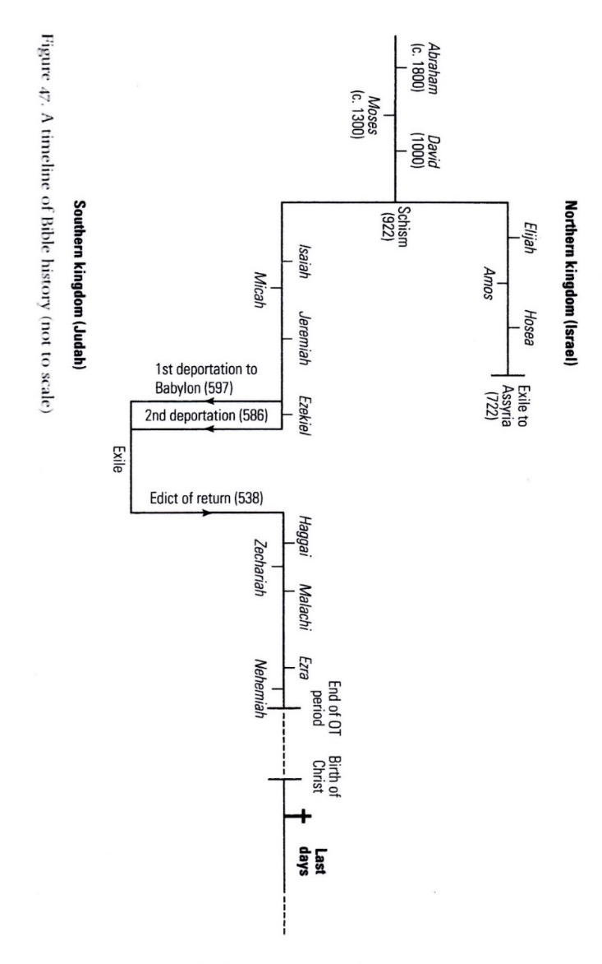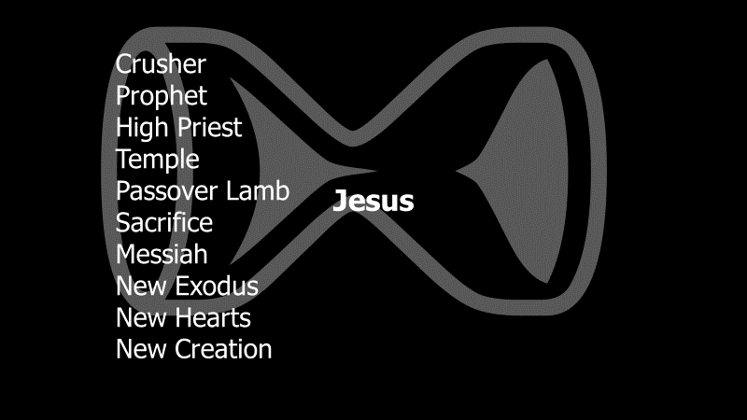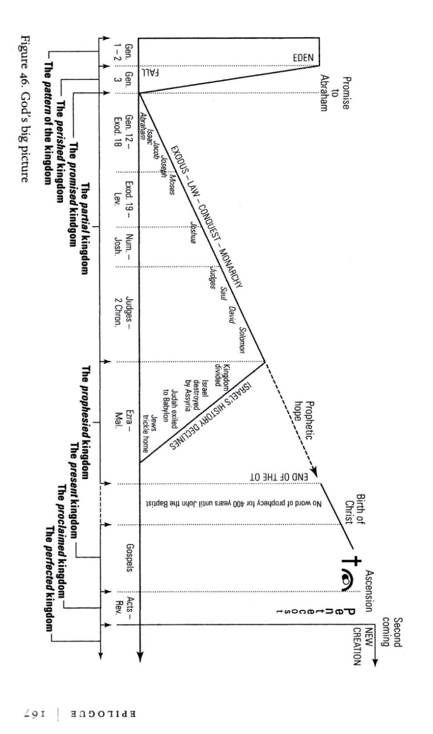

How to read the Bible:
Everything converges on Jesus, like the pinch in an hour-glass, finds it’s fulfilment in him, and emerges the other side changed.

 | Genesis 1&2 | Prototype | Jesus | AD
People | Adam & Eve | Israel
Place | Eden | Canaan
Relationship

SO if we come across a passage about ……..

- Where are we? Locate it on the story-line:
- What aspect of the prototype are we rebuilding? People Land relationship?
- Any development in the Prototype? Between Adam and where we are
- How does Jesus fulfil ….. ?
- Where is ……… now? Push it through the Pinch

